

**BUISNESS PROBLEM**

Analysis of sales data to find patterns, best-selling items, and revenue indicators to help in business decision-

making.

**SOLUTION**

We perform analysis on the data provided and using different methods we try to find the features which can lead to increase in total sales, analyze sales trends over time, the best-selling products.

**DATA USED**

**ECOMM DATA**

1. ORDERS
2. RETURNS
3. PEOPLE

**DETAILED SUMMARY**

1. **Sales Over Years**

The visualization titled "Sales Over Years" depicts the trend of sales over time, specifically from 2011 to 2014.

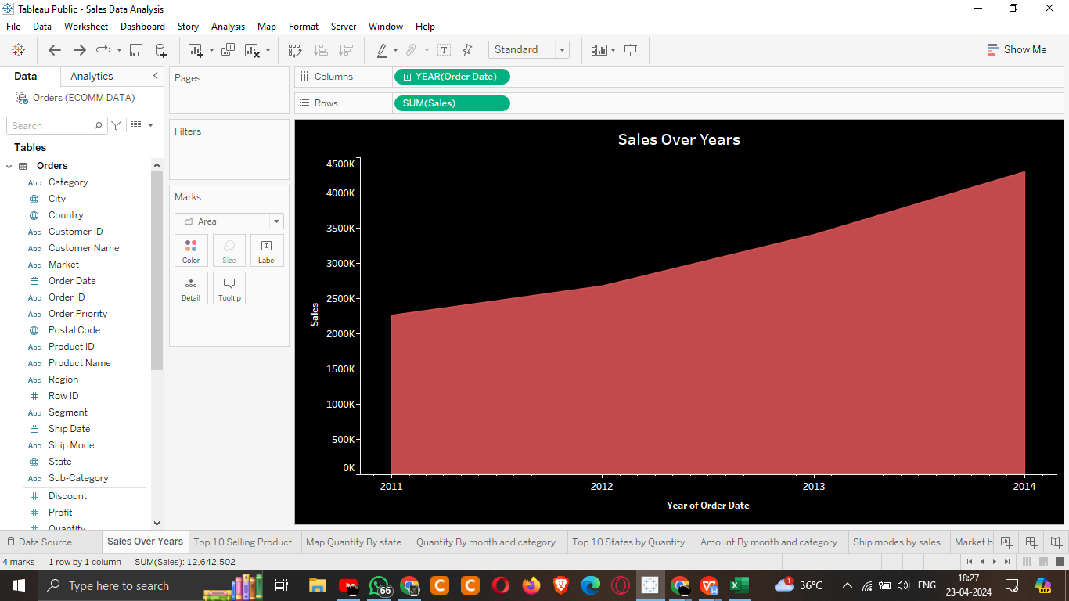**1. Overview of Analysis:**

The analysis shows the sales performance over a four-year period, focusing on the trend of sales volume over time.

**2. Key Insights:**

- Sales have shown consistent growth over the years, with a noticeable upward trend from 2011 to 2014.

- The growth in sales appears to be steady, indicating a positive trajectory for the business.

**3. Performance Overview:**

- Total sales have increased steadily over the analyzed period, with significant growth observed from 2011 to 2014.

- This indicates a healthy sales performance and suggests positive business growth during the period under review.

**4. Recommendations:**

- Capitalize on the observed sales growth trend by investing in strategies to sustain and potentially accelerate this growth.

- Further analyze factors contributing to sales growth, such as marketing initiatives, product offerings, and customer demographics, to refine business strategies.

1. **Top 10 selling product**

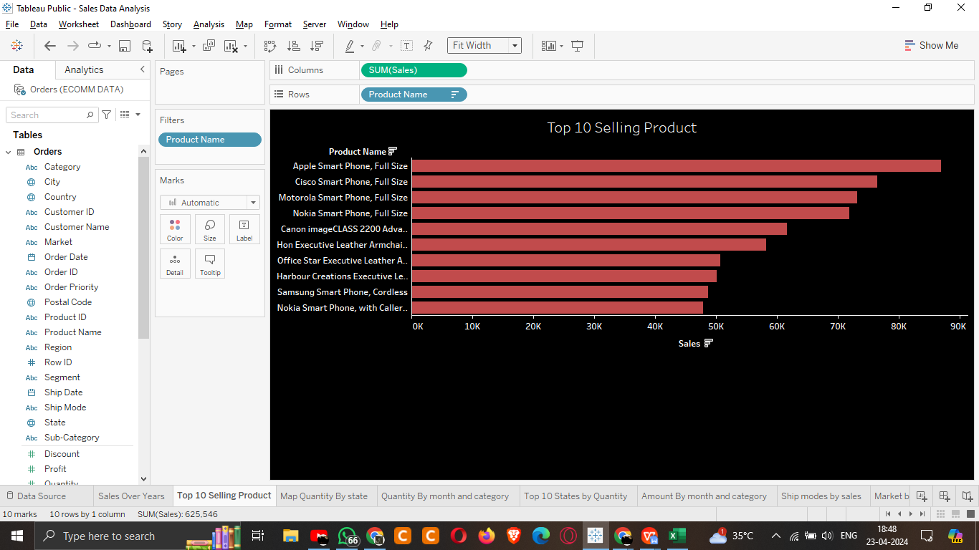The visualization titled "Top 10 Selling Product" presents the sales performance of the top 10 selling products.

**1. Overview of Analysis:**

This analysis focuses on identifying the top-selling products within the data-set, providing insights into the best-performing items.

**2. Key Insights:**

- The visualization highlights the top 10 selling products based on sales volume.

- Among the top-selling products, various types of smart phones and office accessories appear to dominate the sales.

**3. Performance Overview:**

- The sales performance of the top-selling products ranges from approximately 40K to 90K units.

- Products such as "**Apple Smart Phone, Full Size**" and "**Cisco Smart Phone, Full Size**" demonstrate particularly high sales volumes.

**4. Recommendations:**

- Capitalize on the popularity of the top-selling products by ensuring their availability and visibility in marketing campaigns.

- Explore opportunities to bundle complementary products with top-selling items to increase overall sales and customer satisfaction.

- Continuously monitor and analyze sales data to identify emerging trends and adjust product offerings accordingly.

1. **Quantity By month and category**

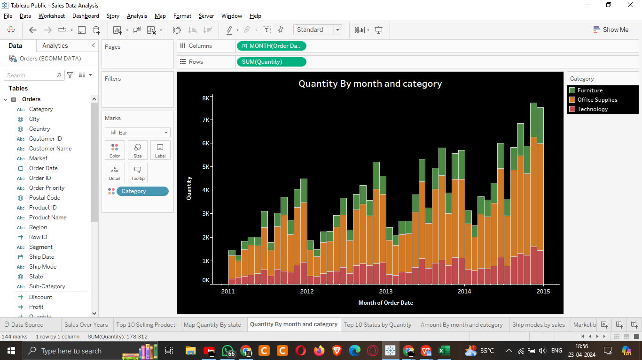The visualization titled "**Quantity By Month and Category**" displays the quantity of products sold categorized by month.

**1. Overview of Analysis:**

This analysis examines the quantity of products sold each month categorized by product category, providing insights into sales trends over time across different product categories.

**2. Key Insights:**

- The visualization illustrates the quantity of products sold each month from 2011 to 2015, categorized into three main product categories: Furniture, Office Supplies, and Technology.

- Each category exhibits varying levels of sales throughout the period, with fluctuations in quantity sold observed across different months and categories.

**3. Performance Overview:**

- The quantity of products sold fluctuates across months and categories, with some months showing higher sales volumes than others.

- Certain categories, such as Technology, appear to consistently have higher sales quantities compared to Furniture and Office Supplies.

1. **Top 10 states by quantity**

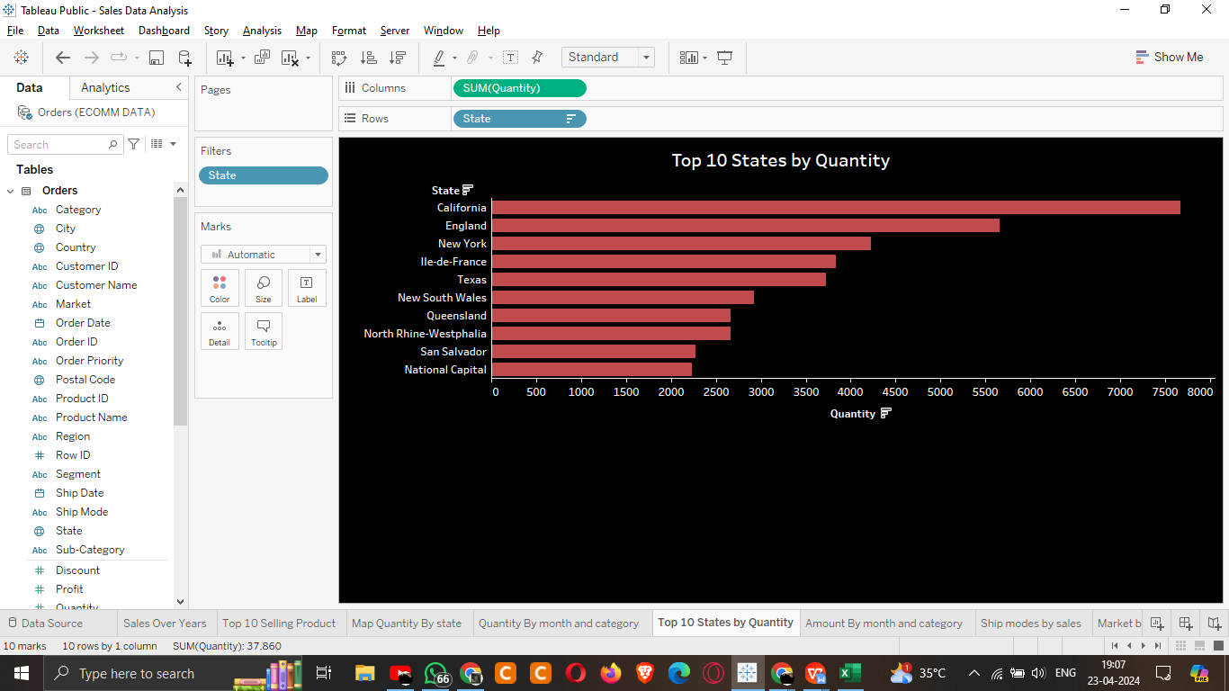The visualization titled "Top 10 States by Quantity" showcases the quantity of products sold in the top 10 states.

**1. Overview of Analysis:**

This analysis identifies the top 10 states by the quantity of products sold, providing insights into sales distribution across different geographic regions.

**2. Key Insights:**

- The visualization highlights the top 10 states with the highest quantity of products sold, ranging from California to National Capital.

- **California** appears to lead in terms of sales quantity, followed by **England** and **New York**, among others.

**3. Performance Overview:**

- The top 10 states exhibit varying levels of sales quantity, with some states significantly outperforming others.

- The quantity of products sold in these states ranges from approximately **3,700** to over **8,000** units.

**4. Recommendations:**

- Investigate opportunities to replicate successful sales approaches from top-performing states in regions with lower sales quantities.

- Leverage regional sales data to tailor marketing campaigns and promotions to the preferences and needs of customers in specific geographic areas.

1. **Amount By month and category**

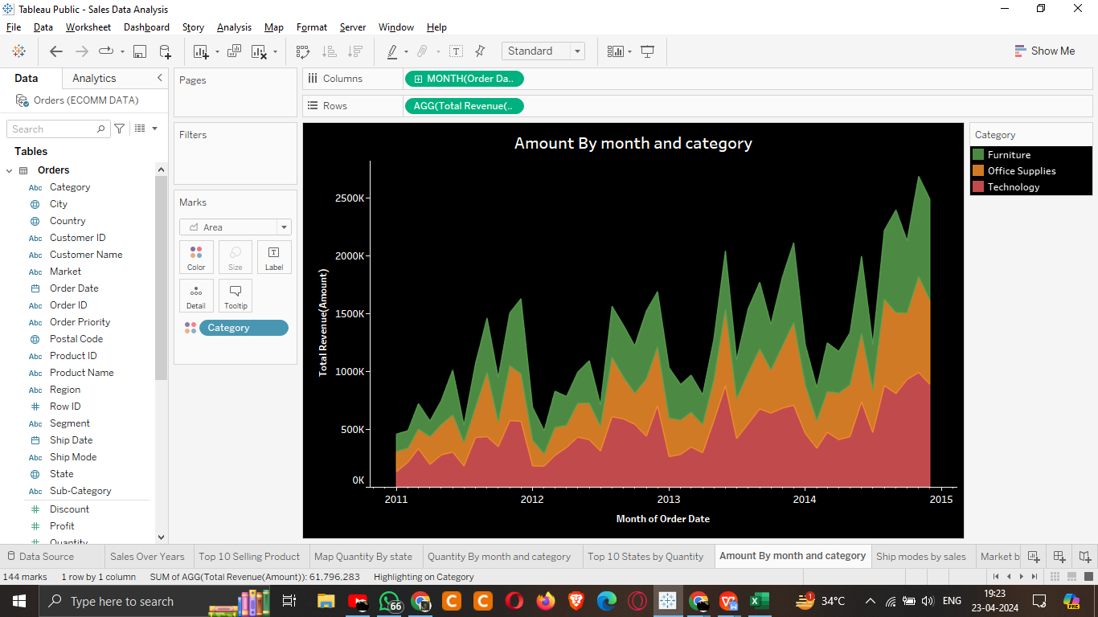The visualization titled "**Amount By Month and Category**" illustrates the total revenue generated each month categorized by product category.

**1. Overview of Analysis:**

This analysis examines the total revenue generated each month, categorized by product category, providing insights into revenue trends over time across different product categories.

**2. Key Insights:**

- The visualization presents the total revenue generated each month from **2011 to 2015**, segmented into three main product categories: Furniture, Office Supplies, and Technology.

- Revenue fluctuations are observed across different months and categories, with varying levels of revenue generated for each category over time.

**3. Performance Overview:**

- Total revenue fluctuates throughout the analyzed period, with peaks and troughs evident in the revenue trends for each category.

- The total revenue generated for each category varies, with some categories consistently contributing more to the overall revenue than others.

1. **Recommendations:** - Analyze the factors influencing revenue fluctuations across different months and categories to identify patterns and potential drivers of revenue growth or decline.

- Develop targeted marketing and sales strategies to capitalize on high-revenue months and address challenges during periods of lower revenue.

1. **Ship modes by sales**

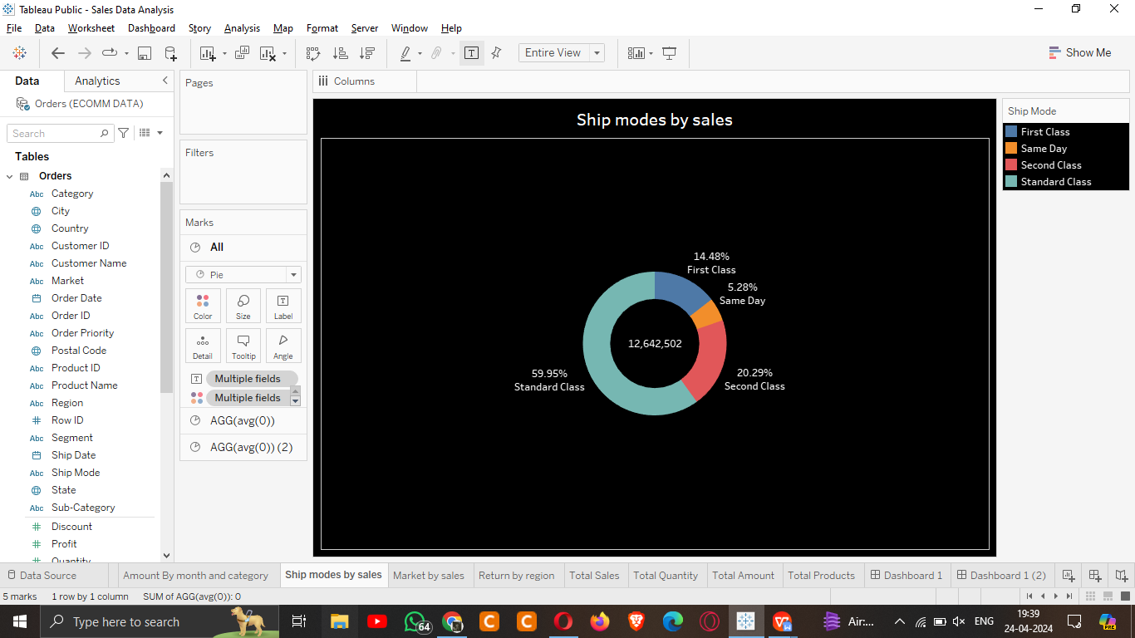The visualization titled "**Ship modes by sales**" presents a donut chart illustrating the distribution of sales across different shipping modes.

1. **Overview of Analysis:**

This analysis examines the distribution of sales across various shipping modes, providing insights into the popularity and utilization of different shipping options.

2. **Key Insights:**

- The pie chart illustrates the proportion of sales attributed to each shipping mode, categorized as **First Class, Same Day, Second Class, and Standard Class**.

- Standard Class shipping appears to be the most commonly used option, accounting for nearly **60%** of total sales.

- Second Class shipping is the next most popular choice, contributing around **20%** to total sales.

- First Class and Same Day shipping options have comparatively smaller shares of total sales, each accounting for approximately 14% and 5%, respectively.

3. **Performance Overview:**

- Standard Class shipping dominates the distribution of sales, indicating that it is the preferred choice for most customers.

- Second Class shipping follows closely behind, suggesting that customers prioritize cost-effective shipping options.

- First Class and Same Day shipping options, while less commonly utilized, still play a role in fulfilling customer orders, particularly for those with specific delivery requirements.

4. **Recommendations:**

- Continue to prioritize and optimize Standard Class shipping services to meet the demands of the majority of customers.

- Explore opportunities to enhance the efficiency and affordability of Second Class shipping to maintain its competitive edge in the market.

- Evaluate the feasibility of offering additional incentives or promotions to encourage greater uptake of First Class and Same Day shipping options among customers.

1. **Market by sales**

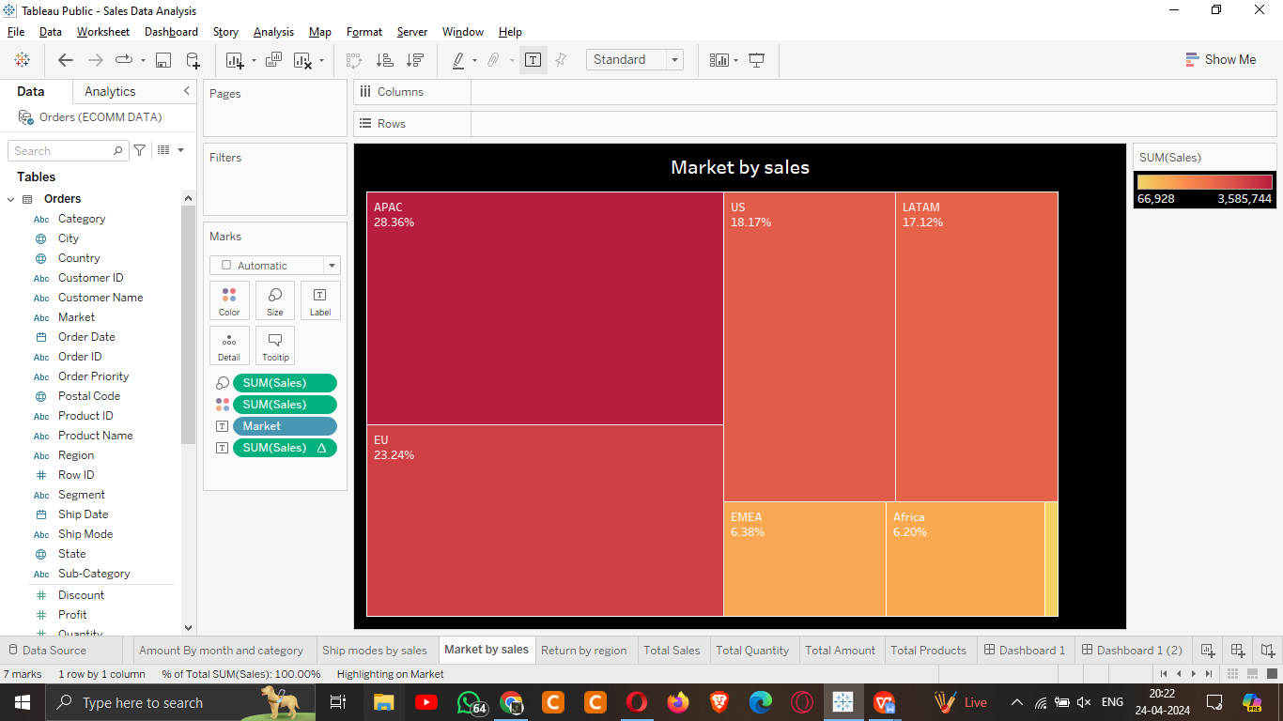The visualization titled "**Market by sales**" provides a tree map of sales across different market regions. Here's an executive summary based on this visualization:

**1. Overview of Analysis:**

This analysis examines the distribution of sales across various market regions, offering insights into the performance of different geographic segments.

1. **Key Insights:**

- The visualization presents a quadrant chart with each quadrant representing a specific market region.

- APAC (Asia-Pacific) emerges as the top-performing market region, contributing approximately **28.36%** to total sales.

- Following closely behind is the US market, accounting for **18.17%** of total sales.

- LATAM (Latin America) and EMEA (Europe, the Middle East, and Africa) regions exhibit moderate sales performance, with shares of approximately **17.12% and 6.38%**, respectively.

- Canada appears to have the smallest share of total sales, contributing around **0.53%** to the overall sales figures.

**3. Performance Overview:**

- APAC and the US markets stand out as the primary drivers of sales, reflecting robust consumer demand and market penetration in these regions.

- LATAM and EMEA regions also demonstrate significant sales contributions, indicating a diverse customer base and market opportunities across different geographic areas.

- Canada, while representing a smaller portion of total sales, still holds potential for growth and expansion with targeted marketing strategies and market development initiatives.

**4. Recommendations:**

- Capitalize on the strong performance of APAC and the US markets by allocating resources and marketing efforts to sustain and further enhance sales growth in these regions.

- Explore opportunities for market expansion and customer engagement in LATAM and EMEA regions to capitalize on their moderate sales performance and tap into emerging market segments.

- Develop targeted marketing campaigns and strategic partnerships to increase market penetration and brand awareness in the Canada market, leveraging its growth potential and untapped opportunities.

1. **Return by region**

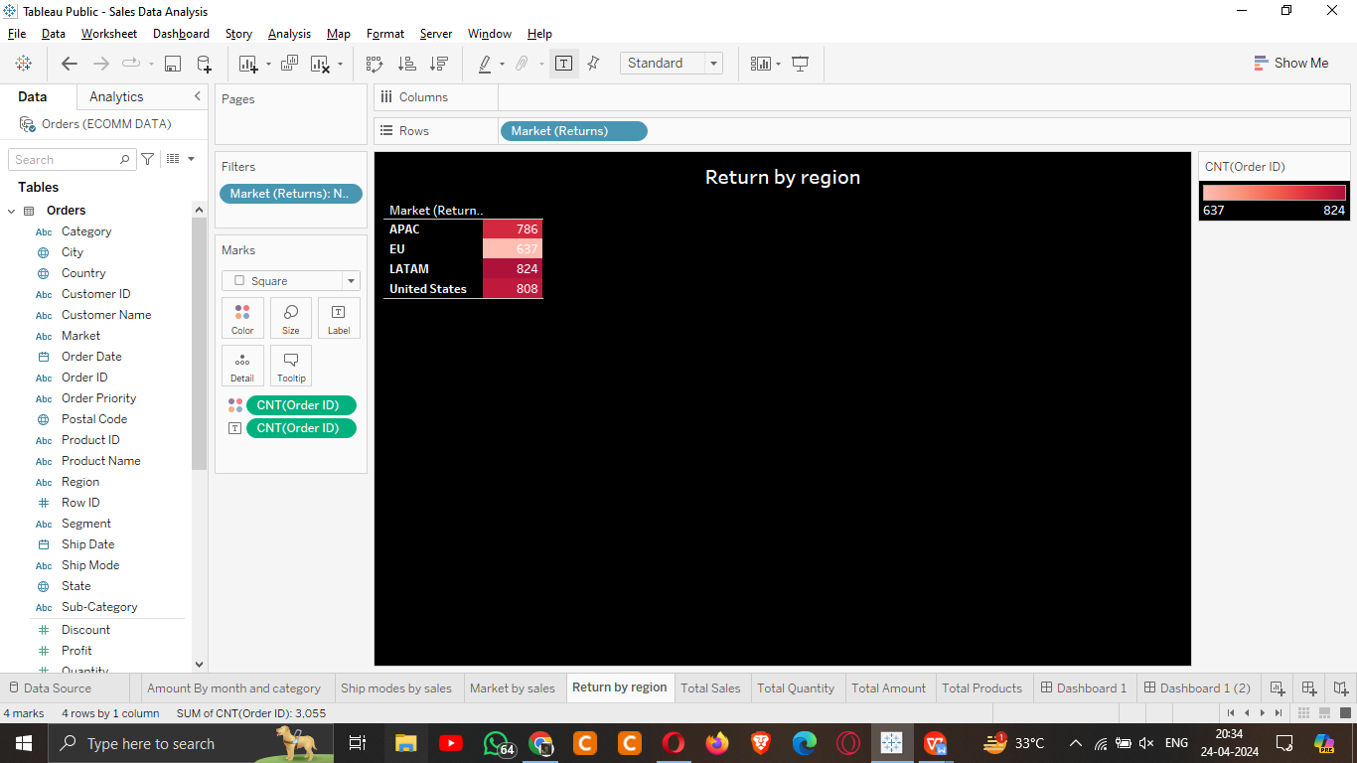The "**Return by Region**" visualization provides insights into the number of product returns categorized by region. It aims to highlight regions with varying return rates, which can help in understanding customer satisfaction levels and potential areas for improvement in product quality or customer service.

**Key Insights:**

1. **LATAM**: With **824** returns, the LATAM region has the highest number of product returns among the regions analyzed. This suggests potential issues with product quality, customer satisfaction, or fulfillment processes in this region.

2. **United States**: The United States follows closely behind with **808** returns, indicating a significant number of returns despite being a major market for sales. This may require further investigation into customer preferences, product expectations, or shipping practices in this region.

3. **APAC**: APAC has **786** returns, making it another region with a considerable number of product returns. Understanding the reasons behind these returns could help in improving customer experience and reducing return rates.

4. **EU**: The EU region has the lowest number of returns among the regions analyzed, with only **637** returns. This suggests relatively higher customer satisfaction or better product quality control measures compared to other regions.

**Performance Overview:**

Overall, the visualization indicates varying levels of customer satisfaction and product quality across different regions. While some regions experience higher return rates, others maintain relatively lower return rates, suggesting potential areas for improvement in customer service, product quality, or fulfillment processes.

**Recommendations:**

1. **Root Cause Analysis**: Conduct a detailed analysis to identify the root causes of product returns in regions with higher return rates such as LATAM, the United States, and APAC. This may involve gathering feedback from customers, analyzing product quality data, or assessing shipping and delivery processes.

2. **Quality Control Measures**: Implement stringent quality control measures to ensure product quality meets customer expectations across all regions. This could involve enhancing product testing procedures, supplier quality management, or packaging standards.

3. **Customer Feedback Mechanisms**: Establish robust mechanisms for collecting and analyzing customer feedback to understand their expectations, preferences, and pain points. This feedback can be instrumental in improving product design, features, and overall customer experience.

4. **Training and Education:** Provide training and education to staff members involved in customer service, sales, and product fulfillment processes. Ensuring staff members are equipped with the necessary skills and knowledge can help in addressing customer concerns promptly and effectively, reducing the likelihood of product returns.

By implementing these recommendations, businesses can work towards reducing product return rates, improving customer satisfaction, and ultimately enhancing overall sales performance and profitability.

